BAPERS
[Document subtitle]
Gerda Morockaite
[Company name]
[Company address]
March 4, 2018

Contents
1 Preface.................................................................................................................................... 3
1.1 Purpose and scope of the document (what it is and what is NOT) .........................
3 1.2 Intended audience and Reading Suggestions..........................................................
3 1.3 History of the document..........................................................................................
3 2 Introduction.............................................................................................................................
3 3 Glossary ..................................................................................................................................
3 4 User requirements...................................................................................................................
4 4.1 System architecture - subsystems and their interfaces............................................
4 .............................................................
4 5 System requirements...............................................................................................................
4 5.1 Purpose and scope of the system.............................................................................
4 5.2 System models........................................................................................................
5 5.2.1 UML use-case models .............................................................................
6 UML Design Models
5 6 System evolution.....................................................................................................................
6 6.1 Users’ Interface & Reports .....................................................................................
6 6.2 Data Stored..............................................................................................................
6 6.3 Further Deployment Platforms................................................................................
7 6.4 Synchronisation Options.........................................................................................
7 6.5 Policy for Releasing Memory Storage ....................................................................
7 7 Appendices..............................................................................................................................
7 7.1 Initial Statement of requirements by the client .......................................................
7 .............................................................................................................. 7
8 Index ....................................................................................................................................... 9

- Preface
  - Purpose and scope of the document (what is it and what it is not)
This is a software requirements document for the BAPERS Software and covers the functional and non-functional requirements with various implementation constraints defined in the initial statement of the requirements by the marketing of LIU LIU TECH
This Document explains what the system shall do but not how the functionality can be implemented. Various models are used to convey in more detail to system.
  - intended audience and Reading suggestions
The staff at BAPERS, Software Developers and Mr Lancaster
  - History of the Document
This is a new document, v 1.0
- Introduction
BIPL is a photographic laboratory that deals with the work of professional photographers by providing a number of standard jobs
The jobs are made up of one or more standard tasks that are performed in their professional laboratory operated by the staff. Special requests can be added to the job as well as the “urgent status” which is a request by the customer for the job to be completed faster than the original deadline which is usually, within 24 hours. The usual “urgent job” must be completed within 6 hours but the customer can also choose 3 hours for a 100% surcharge. The customer can choose an even faster job but at higher rates.
Currently, BIPL can perform 30 standard tasks, each task being uniquely identified and carried out in a specific location in the laboratory.
Each task has an ID, a description, a location in the laboratory, a price and a duration. Once a task is completed, the product is placed in a specific shelf, from where it can be taken for further processing or given to the customer, if completed. Each task has a specific shelf slot.
Most BIPL jobs are priced below 400 GBP, operating at a high-turnover, low profit margin level, with hundreds of jobs operating or pending at the same time.
Whenever a new job is placed, it has to be associated to an existing customer or a newly created one.

- Glossary
BAPERS:
Actor
BIPL
CUST
ACCT
ADMIN

- System requirements
  - Purpose and Scope of the System
  - UML use-case model
  - Use Case Diagram

5.0 System Models
5.1 Use Case Diagram
In the following diagrams, it has been created in packages to represent the different subsystems of BAPERS. We have 6 packages which include ADMIN, CUST, PROC, ACCT, PAYMENT and REPORTS.
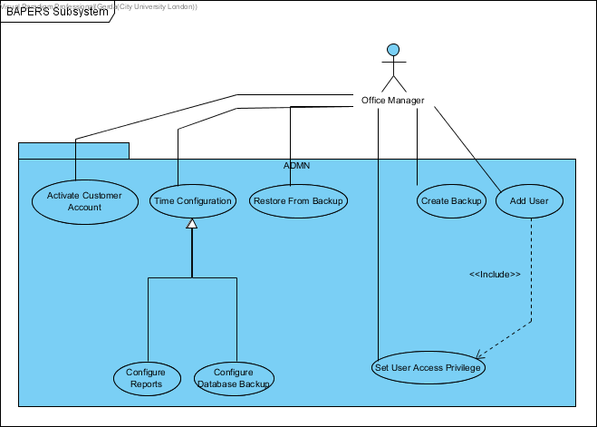
ADMIN
Activate Customer Account: Reactivates customer account marked as ‘in default’.

Time Configuration: Configures the periodicity of automatic functions.

Configure Reports: Changes the frequency of reports.

Configure Database Backup: Changes the frequency of automatic backups.

Create Backup: Manually creates/overwrites system backup.

Add User: Creates a user account for BAPERS.

Set User Access Privilege: Sets up user access privileges.

Restore from Backup: Restores BAPERS from an existing backup.

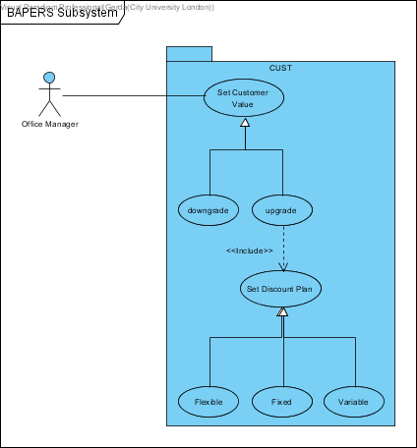

CUST
Set Customer value: office manager chooses to set a customer to a valued customer
Downgrade: office manager can choose to downgrade a customer’s valued status
Upgrade: office manager can choose to upgrade a customer’s valued status
Set discount plan: when a customer is upgraded, the office manager has the option to set up a discount plan according to how many Jobs/tasks a customer has placed.
Flexible: this use case defines the percentage of the discount that depends on the values of the jobs by the same customer accumulated within a calendar month.
Variable: this use case defines the percentage of the discount that is set for each task and may vary between the tasks. The value of this discount is calculated and deducted from the value of the job at the time of accepting the job.
Fixed: this use case defines the same percentage of discount given to the valued customer for each job. The value of this discount is calculated and deducted from the value of the job at the time of accepting the job.
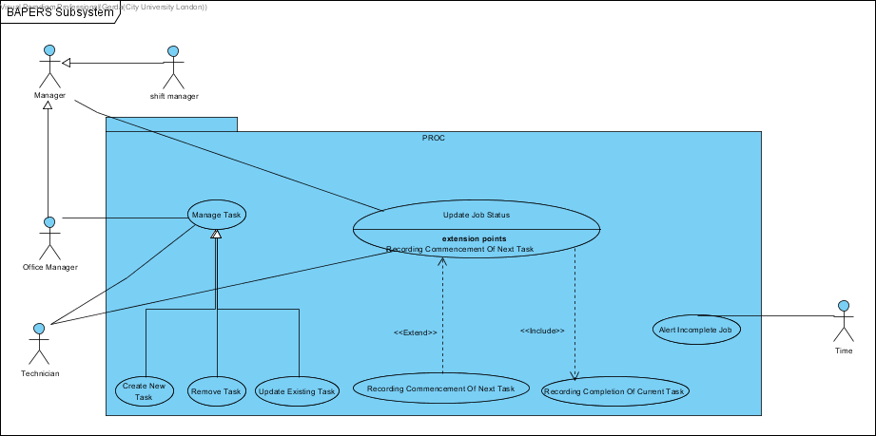

PROC
Manage Task: Edit the tasks that exist in the system, add or delete them
Create New Task: Add a new task to the list of existing tasks
Remove Task: Delete a task from the list of existing tasks
Update Existing Task: Update any changes made to an existing task
Update Job Status: Update the status of an ongoing job and the tasks it has performed or are about to be performed. The commencement and completion of tasks are recorded here
Alert Incomplete Job: Alerts the customer if the job they placed cannot be completed of the job at the time of accepting the job.

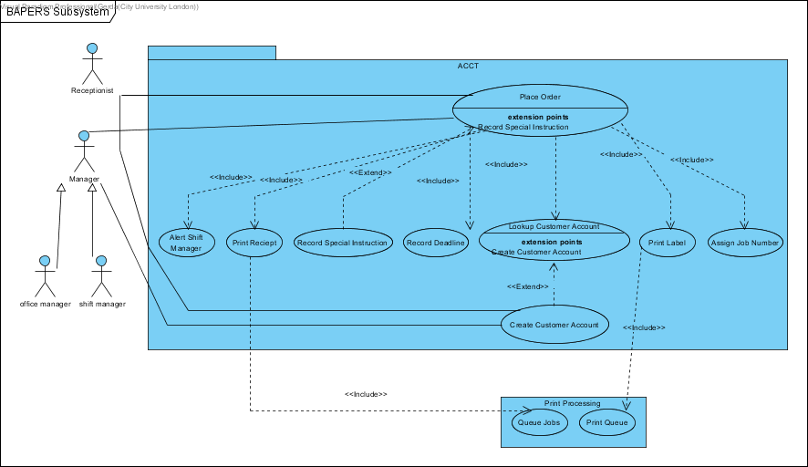
ACCT
Place Order: The actor (Managers or Receptionist) placing the order on behalf of the customers.
Alert Shift Manager: To alert the shift manager there is a new job arrive and should be process.
Print Receipt: Print a receipt for the customer about the job he/she order.
Record Special Instruction: Record additional requirement from the customer.
Record Deadline: Record the required job end time.
Lookup Customer Account: Search the customer account in order to identify the identity of the customer.
Create Customer Account: creating a new instance of customer account due to the very first order from the new customer.
Print Label: Print the label for materials required for job.
Assign Job Number: Generate a number for the job which is unique compare to other jobs.

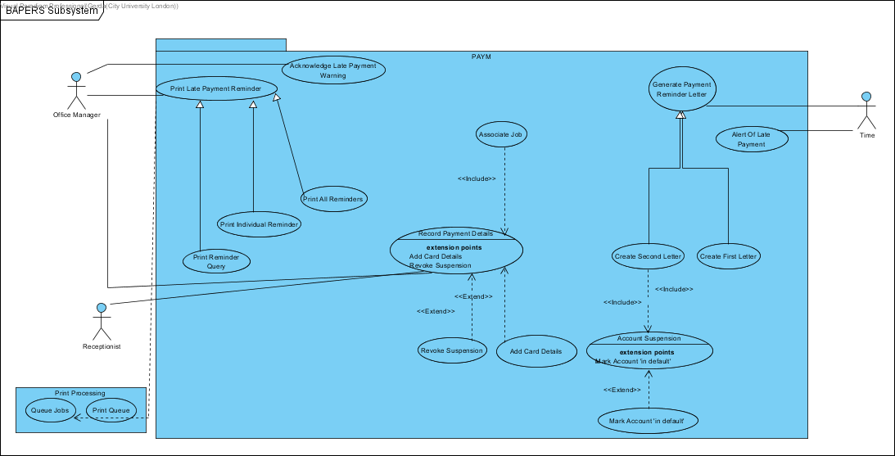
PAYMENT
Print Late Payment Reminder: when a late payment is made, a late payment reminder is created which can then be printed by the office managers discretion.
Print Reminder Query: this use case gives the option/functionality to the office manager to print whichever late payment reminder they want.
Print Individual Reminder: This prints the late payment reminder for a single job. It prints the latest job reminder.
Print All Reminders: Prints all the late reminders that have been stored.
Acknowledge Late Payment Warning: the office manager gets alerts of late payments to his/her computer, and the office manager acknowledges these late payment warnings.
Record Payment Details: once the customer pays for the completion of the job payment method and details are recorded.
Revoke Suspension: when a customer account is suspended, and a payment is made from that account. The suspension on that account is revoked and the account is reactivated automatically.
Add Card Details: if the customer is paying with card, card details are recorded such as expiry date, type and last 4 digits.
Associate Job: each payment needs to be associated with a job. This checks the payment with the job ensuring the payment is for the right job.
Generate Payment Reminder Letter: triggered automatically, when valued customers are unable to clear the outstanding balance, a late payment reminder letter is generated.
Create First Letter: generates the first late payment letter.
Create Second Letter: generates the second late payment letter.
Account Suspension: after the second letter is created the account associated with it is suspended automatically.
Mark Account “in default”: a month after the second letter has been sent and the outstanding balance has not been cleared the system marks that account as “in default” automatically.
Alert of Late Payment: automatic alerts of late payments are shown to the office manager as pop-up windows in 15 minutes intervals.

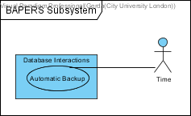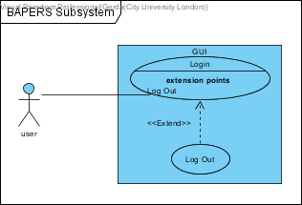
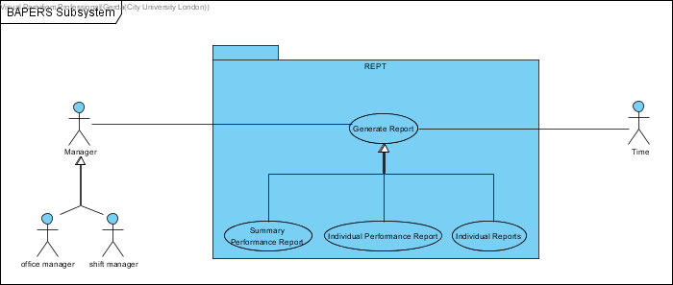
need to add description for these two

REPORT
Generate Report: Generate a report according to the type according to the user (Office Manager) chosen.
Summary Performance Report: Generate the report about summary performance with the data’s stores in the database.
Individual Performance Report: Generate the report about individual performance with the data’s stores in the database.
Individual Report: Generate the report about individual with the data’s stores in the database.

6.0 Design Class

6.1 Package Diagram
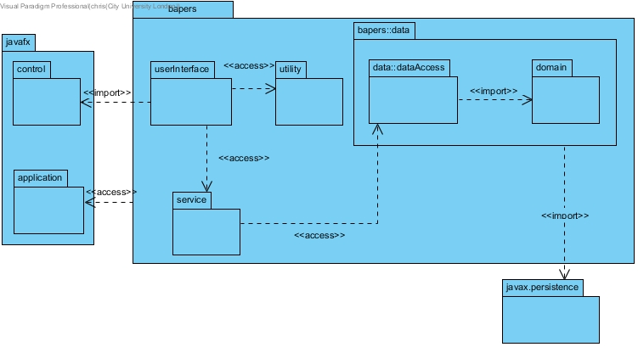
DB connectivity is modelled with the expectation of using the eclipselink library, which is an implementation of JPA, hence the import to javax.persistence. I have simplified the diagram by not showing the persistence unit, as this will be autogenerated by the chosen IDE, making it redundant to show it in the class diagram.
The persistence unit will need to include the following property: <property name="javax.persistence.jdbc.url" value="jdbc:mysql://localhost:3306/bapers?zeroDateTimeBehavior=convertToNull&amp;autoReconnect=true&amp;useSSL=true"/>
The userInterface will utilise javaFX; each form will have three separate files, a bapers::fxml::form.fxml, bapers::styles::form.css and bapers::FormController.java. The fxml file details objects within the form, and their respective location, and the controller class will describe the behaviour of the forms objects. However, for the sake of brevity, I have simplified this for the class diagram by bundling all three files into a single boundary class, and making the userInteface package, where they will be stored.

6.1 Simplified Design Class Diagram
The following diagram presents the full class diagram; however, all classes have been stripped of their members. This is to concisely show all associations. Full details will be provided in section 1.3.
Please note that the javax.persistence package appears more than once. This was to allow for neater formatting of the diagram, all repeated instances should be treated as part of the same package. This also applies to any other repeated packages/classes.

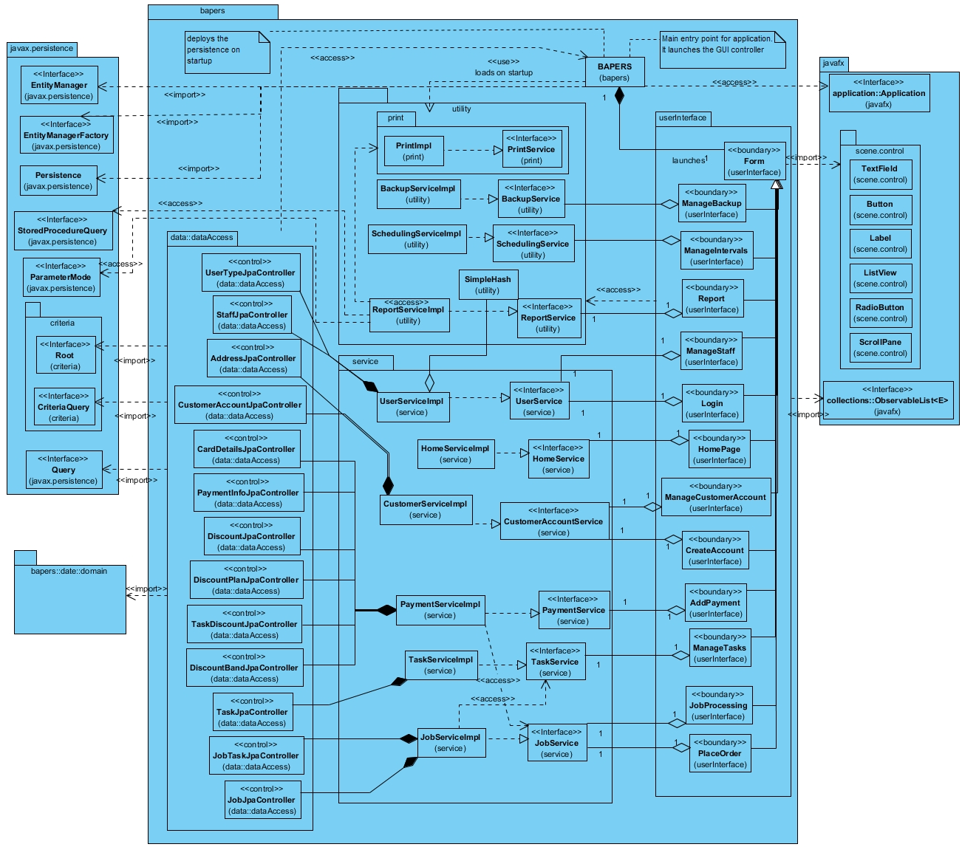
6.2.1
This diagram excludes all entities from the bapers::data::domain package, as the associations for that package will be shown in the detailed diagram in section 1.3.

Use Case Indexing
In this section, a list is created to rank the most important use cases we believe are necessary for the functionality of BAPERS.
UC priority number | Use case
1 | Place Order
3 | Create Customer Account
2 | Lookup Customer Account
4 | Log In
5 | Record Payment Details
6 | Update Job Status
7 | Add User
8 | Configure Database Backup
9 | Upgrade Customer Value
10 | Update existing Task
11 | Print Late Payment Reminder
12 | Generate Report
13 | Log Out
14 | Create Second Letter
15 | Remove Task
16 | Recording Commencement Of Next Task
17 | Alert Incomplete Job
18 | Assign Job Number
19 | Record Payment Details
20 | Alert Shift Manager
21 | Print Label
22 | Add Card Details
23 | Set User Access Privilege
24 | Activate Customer Account
25 | Record Completion Of Current Task
26 | Log Out
27 | Create Backup
28 | Restore From Backup
29 | Account Suspension
30 | Configure Reports
31 | Associate Job
32 | Automatic Backup
33 | Set Customer Value
34 | Downgrade
35 | Upgrade
36 | Alert Of Late Payment
37 | Acknowledge Late Payment Warning
38 | Generate Payment Reminder Letter
39 | Print Receipt
40 | Print Reminder Query
41 | Print Individual Reminder
42 | Print All Reminders
43 | Print Queue
44 | Create First Letter
45 | Manage Task
46 | Make Account ‘in default’
47 | Set Customer Value
48 | Downgrade
49 | Create New Task
50 | Time Configuration
51 | Set Discount Plan
52 | Revoke Suspension
53 | Record Special Instructions
54 | Summary Performance Report
55 | Individual Performance Report
56 | Individual Reports

Insert here – Risk Analysis (missing reports +
ADMIN
- Activate Customer Account: Reactivates customer account marked as ‘in default’.
  - The importance of this use case is high because this enables the customer account to be reactivated and useable. The risk of not having this use case means that we would have idle customer accounts in our database, which takes money for space and those customers with that account would not be able to demand any more to-do jobs until this is fixed. This is also a potential risk to push our customers away.

- Time Configuration: Configures the periodicity of automatic functions.
  - This is important for all automatic timely events and functions that take place within the system. The reason being that this use case sets the time for those functions to occur. Doing this it will ensure that all databases and reports will be backed up automatically and the latest versions are available in case of data loss or server downs. Also, this is helpful because it is very possible that the users forget to backup the data manually thus, this removes that human error. If this was not to be implemented correctly this could lead to loss of access to specific data when need in case of services down such as database server downs.

- Configure Reports: Changes the frequency of reports.
  - This is directly linked to the Time Configuration use case as initially it is setup from that use case, but this use case allows you to change the automatic backup of the reports. This is an appropriate use case that can be used to automatically backup the reports to meet your requirements. Moreover, this is very useful because it is possible that the users forget to create the report backup and they would be able to keep track of progress and report backups.

- Configure Database Backup: Changes the frequency of automatic backups.
  - This is directly linked to the Time Configuration use case as initially it is setup from that use case, but this use case allows you to configure the automatic backup of the database. This is important as you need regular updates of the database in case of data loss or inaccessibility of the database. That way you don’t lose all the information that you had in your database. Moreover, it is good to have automatic backups as it is very likely for the users to forget to create regular backups and they would be able to monitor and keep track of their database and can be used for analysis.

- Create Backup: Manually creates/overwrites system backup.
  - Being able to create a backup when necessary is important. The risks of not being able to do this include the fact that if your servers/databases were to crash or fail, our system would be down until fixed. However, with a backed-up database we can continue to work with the latest information from the backup. Having the system down will result in a major financial loss as for that period of time the system was not being used. This would also be more time efficient because as we continue to work of the backup we can proceed to fixing the main server. Also, this allows the backing up any important data as soon as it is entered in the system, rather than having to wait for the timely backups.

- Add User: Creates a user account for BAPERS.
  - The risk of not implementing this would include the fact that you would have no users for the system thus no coordination and no access to the software functions. To be able to use certain functions/the system you are required to have an account and without it your access will technically be blocked and unusable. This would result to you having to continue to process jobs, tasks etc. the entire process as you have done prior to this software, which is time consuming and much costlier.

- Set User Access Privilege: Sets up user access privileges.
  - This is important to set what each user can do in the system. What access they have, what functions they can use, what their responsibilities are etc. The risk of not having this can be drastic, for example if all users have access to changing a job status/demands and everyone is changing those requirements and statuses this can cause confusion between the employees and can effect the completion of the job. Which will result in unsatisfied customers and we would have to amend the job to satisfaction, which will result in more cost and time. Therefore, it is important to set user privileges that allows access according to your user account type.

- Restore from Backup: Restores BAPERS from an existing backup.
  - This follows from the Create Backup use case. If we encounter a problem with the system/ system data and it is no longer useable we need to be able to restore the system to a working backup so that it does not halt the jobs that need to be done, because consequently if we do not have this backup functionality this will result in money loss, data loss, server space loss and dissatisfied customers. Making this use case very important.

ACCT
- Place Order: The actor (Managers or Receptionist) placing the order on behalf of the customers.
  - The risks involved in not having this use case implemented properly is that no job will be entered into the system thus the system would be useless as it won’t be used, as a job is required to be processed and go through all the other necessary functions to complete a job. This would result in a waste of database space and money as we paid for it, but it is not being used. Moreover, customers would be dissatisfied with uncompleted jobs and a waste of their time, which would push customers away.

- Alert Shift Manager: To alert the shift manager there is a new job arrive and should be process.

  - This is an important use case to be implemented as it relays information to one of the heads of the managers with high privileges in the system, the shift manager. If this use case was not to be implemented properly, this would mean that the shift manager would not be notified on the new jobs that come in and he would not redirect them, manage them (oversee them) and would not be able to process them. Moreover, this can cause confusion of unknown jobs being entered into the system which the manager may think the system needs checking which takes time and money, so wouldn’t be efficient. Also, this would leave a gap in his knowledge of processing jobs which can cause problems for him/her when asked questions or talking to customers.

- Print Receipt: Print a receipt for the customer about the job he/she order.
  - The risk of not having this use case implemented means that the customer would not have solid proof of the job order that they have given BILP. Moreover, it’s important for the business to have proof of the jobs they have taken in case of any legal issues or customer complaints, they can refer to the receipts to counter their arguments. If this use case was not to be implemented correctly this could have a negative impact on the income and potentially time.

- Record Special Instruction: Record additional requirement from the customer.
  - This is a necessary additional functionality to enable customers to have their input on certain tasks and must be implemented correctly. If this was not implemented there is the risk of the tasks not being completed to the customer satisfaction and having missed out key elements that is required to complete the job. This can cause customers wanting a refund as expectations were not met and to reprocess the job (finishing the job by adding the missed-out details), which will take more time and can halt taking in more jobs. This can have a negative impact on the income and time efficiency thus making it important that this use case is implemented correctly.

- Record Deadline: Record the required job end time.
  - Recording the deadline is important for several reasons that involve both the business and the customers. The most important being so that we can deliver the completed job on time to the customer and ensuring that they are satisfied. This in turn will bring them back to our business as they were pleased with the service and quality of the job. If there was no deadline the business could take a time to complete it and delivery to customers would be inconsistent which would make them dissatisfied. Furthermore, it doesn’t show an indication of what priority level the job has. This would cost us our time, database space and money negatively.

- Lookup Customer Account: Search the customer account in order to identify the identity of the customer.
  - This is an essential use case that needs to be implemented correctly otherwise this can risk creating duplicated customer accounts and unmatched/linked jobs, which will create confusion in the team and take up more database space and time as more accounts are being made than necessary and searched. Moreover, then one job could be linked to multiple customer accounts which cannot happen. Being able to search up customers gives us the ability to search valuable information that is associated with that customer. Thus, it is important to ensure this use case is implemented correctly.

- Create Customer Account: creating a new instance of customer account due to the very first order from the new customer.
  - This is closely linked to the Lookup Customer Account use case and is very important. The risks of this not being implemented correctly include that jobs given to BILP will have no customer associated with it, meaning that the team would not know who these jobs belong to. This can cause major confusion and can potentially lead to not doing the job as it belongs to no one. Moreover, there would be no data/information about the customer so there would be no way to contact them or get payed or get other specific details. Therefore, it is important that this is conducted correctly and linked to one customer and their jobs only.

- Print Label: Print the label for materials required for job.
  - The risk of this not being implemented include that the job cannot be completed as the teams updating/doing the job will not know what the customer wanted/what materials are required, thus don’t know what to do to the picture or what is required to complete the process. This will affect team coordination and time as constant communication will be required to answer queries they will have about the job and the materials required.

- Assign Job Number: Generate a number for the job which is unique compare to other jobs.
  - This is important to help coordinate the job pool. This will also allow the team to access jobs easier by just calling the job number rather than the job name or customer associated with it. This is more time efficient. Alternatively, this risks job confusion with other jobs and can make it less time efficient if this is not implemented.

CUST
- Set Customer value: office manager chooses to set a customer to a valued customer
  - This functionality is important to be implemented because there are other functions that can be carried out after this has been done. The risk of this not being implemented correctly effects the types of discount that the customer can get, as only when a customer is valued can they be given a discount plan and other functions would not be used thus taking up more space and code that is not used.

- Downgrade: office manager can choose to downgrade a customer’s valued status
  - This is directly linked to the Set Customer value use case. Its important that this is implemented correctly so that the manager can change a customer account from valued to non-valued. This is important because if this was not available customers that became valued customers would stay valued customers even if they don’t reach the requirements for the valued customer status. Thus, they could still have the discounts which would result in the company/business making a loss which is a major risk therefore, this needs to be implemented correctly.

- Upgrade: office manager can choose to upgrade a customer’s valued status
  - This is directly linked to the Downgrade and Set Customer value use cases. This is important and must be implemented because this is the use case that triggers the other use cases. Not implementing this will mean that we are unable to update the valued status of the customer which will cause risks and problems as explained in the other two related use cases.

- Set discount plan: when a customer is upgraded, the office manager has the option to set up a discount plan according to how many Jobs/tasks a customer has placed.
  - When a customer account is upgraded to a valued customer account they then get a discount plan. This use case sets the discount plan to that account therefore is a necessity. If this use case was not to be implemented correctly this would lead to the manager not being able to give the valued customer a discount plan which can then lead to unvalued customers, consequently leading to less customers and dissatisfaction. Moreover, it would make the previous three use cases useless (Set Customer value, Downgrade, Upgrade).

- Flexible: this use case defines the percentage of the discount that depends on the values of the jobs by the same customer accumulated within a calendar month.
- Variable: this use case defines the percentage of the discount that is set for each task and may vary between the tasks. The value of this discount is calculated and deducted from the value of the job at the time of accepting the job.
- Fixed: this use case defines the same percentage of discount given to the valued customer for each job. The value of this discount is calculated and deducted from the value of the job at the time of accepting the job.

These are the various discount plans use cases that are available to the manager than he can set for the valued customers. These use cases are directly linked to the Set discount plan use case as that use case then refers to one of these for implementation. If these are not implemented correctly it would make the Set discount plan use case useless as there would be no discount plan that can be set for the valued customer. Moreover, this would also be a waste of memory/space as it is a use case that would not be able to complete its functionality. Therefore, to avoid this risk it is important that these use ca

Use Case Specifications
This section includes the 10 key use case specifications that were made for BAPERS
Formatting of top two need to change to match others. (Record payment + alt flows)
Use Case ID: Use Case: Record Payment
Brief Description: Once a customer makes a payment with BAPERS, a record of the payment is then stored in the local memory of the machine running the system and then the record is stored in the database.
Primary Actors: Office Manager, Receptionist
Secondary Actors: Database Server
Preconditions:
- The system is operational
- Either the Office Manager, or the Receptionist is logged into the system and had chosen the GUI option to record a payment from a client.
Main Flow:
- The use case starts when the Office Manager, or receptionist selects Record Payment functionality.
- The GUI prompts the user to then enter the payment details including: amount paid, whether the payment is card or cash.
- The GUI then sends the input information to the system, and the system creates a payment object.
- The system then finds the outstanding (unpaid) jobs for the customer, and adds them to the payment object.
- The system contacts the Database Server, and sends the payment object to be stored on disk.
- The system deletes the local payment object.
- The system alerts the user that payment has been added.
Postconditions:
- The database contains a new payment record
Alternative Flows:
CardPayment
NoConnectionToServer
UnSuspendAccount

Use Case ID: Use Case: Record Payment : CardPayment
Brief Description: The customer has made a payment with a card, so the card details will be added to the system.
Primary Actors: Office Manager, Receptionist
Secondary Actors: Database Server
Preconditions:
The system is operational and Either the Office Manager, or the Receptionist is logged into the system and had chosen the GUI option to record a payment from a client.
Alternate Flow:
- The flow may start at step 2 of the main flow.
- The GUI prompts the user to enter card details.
- While (more cards)
  - The user enters card details.
- The GUI sends the information to the system, and the system then creates a card object, and a payment object. Giving the payment object a reference to the card object.
- The flow should resume at step 2 of the main flow.
Postconditions:
Local storage contains a Card Details Object, which is referenced by a Payment object.

Use Case ID: Use Case: Record Payment : NoConnectionToServer
Brief Description: A connection cannot be established with the database server, so the operation is aborted.
Primary Actors: Office Manager, Receptionist
Secondary Actors: Database Server
Preconditions:
The system is operational and either the Office Manager, or the Receptionist is logged into the system and had chosen the GUI option to record a payment from a client.
Alternate Flow:
- The flow may start at step 5 of the main flow.
- The system informs the user that no communication channel can be established to the database.
Postconditions:
The contents of the database are unchanged

Use Case ID: | Use Case: Generate 2nd Letter

Brief Description: BAPERS automatically generate the second letter to the Office Manager which going to be send to the customers.
Primary Actors: Time
Secondary Actors: Office Manager
Preconditions:
- First letter has been generated and sent to customer.
- One month after the first letter is sent and payment yet to be receive.
- Office Manager logs into his/her account.
Main Flow:
- The Use case starts when it is a month after the first letter sent out.
- BAPERS suspend the corresponding customer’s account.
- BAPERS awaits User with user type Office Manager to Log-in.
- BAPERS alert the Office Manager and second letter is prepare for him/her to print.
- BAPERS connects to a printer with existing communication channel.
- BAPERS inform the Office Manager the print has been completed.
Postconditions:
- The letter successfully printed out by the Office Manager with no error occur.
Alternative Flows:
NoPrinterConnection

Use Case ID: N/A | Use Case:  Generate 2nd Letter:NoPrinterConnection

Brief Description: Printing error due to lack of communication with the hardware printer.
Primary Actors: NA
Secondary Actors: NA
Preconditions:
- BAPERS is operational.
- Office Manager logs into BAPERS.
- Office Manager receive the alert of the second letter.
- Office Manager chosen to print the second letter.
Main Flow: NA
Postconditions: The letter is not print on demand by the Office Manager.
Alternative Flows:
- The flow may start at step 5 of the main flow.
- BAPERS informs the Office Manager that no communication between the printer and the computer can be located.

Use Case ID: | Use Case: Create User

Brief Description: Office Manager creates an user account for BAPERS.
Primary Actors: Office Manager
Secondary Actors: NA
Preconditions:
- BAPERS is operational.
- A user with user type Office Manager has logged into BAPERS.
Main Flow:
- The use case starts when the Office Manager selects “Create User” functionality.
- Office Manager input details for the user account.
- Office Manager setting up privileges for the account.
- BAPERS connect with the database with existing communication channel and send details of the new creation account to it.
- BAPERS informs Office Manager that a user account has been successfully created.
Postconditions:
- The database contains the new account details.
Alternative Flows:
NoCommunicationChannel

Use Case ID: N/A | Use Case:  Create User:NoCommunicationChannel

Brief Description: Creation error due to lack of communication channel between BAPERS and the database.
Primary Actors: NA
Secondary Actors: NA
Preconditions:
- BAPERS is operational.
- User with user type Office Manager logged into BAPERS.
- Office Manager chosen to create user.
Main Flow: NA
Postconditions: User account details in the database remain unchanged.
Alternative Flows:
- The flow may start at step 4 of the main flow.
- BAPERS informs the Office Manager that no communication channel can be located.

Use Case ID: | Use Case: Automatic backup

Brief Description: BAPERS backs up the database server each time period specified.
Primary Actors: Time
Secondary Actors: Database server
Preconditions:
- BAPERS is operational.
- Automatic backup period is specified.
Main Flow:
- Use case starts when specified time occurs.
- BAPERS backs up the Database server.
Postconditions:
- The database server is backed up/replaces the old backup.

Alternative Flows: NoCommunicationChannel

Use Case ID: | Use Case: Update existing task

Brief Description: Edit existing tasks from the task list.
Primary Actors: Office manager
Secondary Actors: Database server
Preconditions:
- BAPERS is operational.
- Primary actor is logged in to BAPERS.
Main Flow:
- Use case starts when the User selects “Update existing task” functionality.
- Tasks are retrieved from the database server
- User selects a task.
- User updates the details of the task
- BAPERS updates the task.
- BAPERS informs user that the task has been updated.
Postconditions:
- The database server contains updated task; all previously stored tasks are unchanged.
Alternative Flows:
NoCommunicationChannel

Use Case ID: N/A | Use Case: Automatic backup:NoCommunicationChannel

Brief Description: Automatic backup unavailable due to lack of communication channel.
Preconditions:
- BAPERS is operational.
- Automatic backup period is specified.
Alternative flows:
- The flow may start at step 2 of the main flow.
- BAPERS informs the User that no communication channel can be located

Postconditions: The database server is not backed up. The database server is not backed up.

Use Case ID: N/A | Use Case: Update existing task:NoCommunicationChannel

Brief Description: Task updating unavailable due to lack of communication channel.
Preconditions:
- BAPERS is operational.
- Primary actor is logged in to BAPERS.
Postconditions: The content of tasks in database server remains unchanged.
Alternative Flows:
- The flow may start at step 2 of the main flow.
- BAPERS informs the User that no communication channel can be located

Use Case ID: | Use Case: UpgradeCustomerAccount

Brief Description: Upgrade important customers to the “Valued” status, enabling them to benefit from different discounts.
Primary Actors: Office Manager
Secondary Actors: Database
Preconditions: The system is functional and the Office Manager logs in to the system
Main Flow:
- The Use Case starts when the Office Manager logs into the system
- The Office Manager accesses the customer list
- The Office Manager selects the customer
- The Office Manager clicks the GUI button for upgrading the customer to the “Valued” status
- When the button is clicked, the system fetches the value from the database
- The system creates an object into the system where it stores the value
- The system changes the old value with the new value
- The data is sent back by the system to the database
- The database overwrites the old status with the new status.

Postconditions: The database is updated with the new customer status and the customer is eligible for discounts
Alternative Flows: The account is already upgraded

Use Case ID: N/A | Use Case: UpgradeCustomerAccount : InvalidAccountUpgraded

Brief Description: The system informs the Office Manager that the account he is trying to upgrade is already upgraded
Preconditions: The Office Manager has tried upgrading an account that is already upgraded
Alternative Flows:
- Alternative flow begins at step 4
- The Office Manager clicks the GUI button for updating the user status
- The system fetches the data from the database
- The system compares detects that the change already took place
- The system displays the error message
- The system does not send any information back to the database and deletes the object created

Postconditions: The database is not modified

Use Case ID: | Use Case: PrintLateReminder

Brief Description: Print the late payment reminder for the customer who did not pay in time for the service.

Primary Actors: Office Manager

Preconditions: The system is functional; the Office Manager logs in to the system and the customer exceeded the payment deadline

Main Flow:
- The screen displays the notification that a customer has exceeded the payment deadline
- The Office Manager Clicks the GUI button for printing the letter
- The letter is printed

Postconditions: The Database is updated with the information of a user having a letter printed for

Alternative Flows: PrinterError

Use Case ID: N/A | Use Case: PrinterError

Brief Description: Office manager is unable to print the letters required as a print error occurs
Primary Actors: N/A
Secondary Actors: N/A
Preconditions: The system is functional; the Office Manager logs in to the system and the customer exceeded the payment deadline
Postconditions:
Alternative Flows:
- Flow may start at step 2 of the main flow
- There is a printer error when trying to print the letter

Use case ID: | Use case: Login
Brief Description: The procedure where the users/staff can login to the BAPERS system so that they can use the system and its functions.

Primary actors:
- Receptionist
- Shift Manager
- Office Manager
- Technician

Secondary actors:
- Database server

Preconditions:
- System is operational, the system has a secure connection to the database server.
- The primary actors must be authorised.

Main flow:
- The use case starts when the user selects the “Login” button.
- The system opens another page where the user is told to enter their login details in the space provided.
- The user then presses the login button.
- The system then searches the database for corresponding login details.
  - Corresponding login details are not found. While not found:
    - System tells user: invalid username or password.
    - System tells user to check and re-enter their username and password.
  - The user then clicks the login button again.
- User then login
- Use case completed.

Postconditions:
- The user login and the software and its functions are accessible to the user.

Alternative flows:
- Login fails due to incorrect login details.

Use case ID: N/A | Use Case: Login: LoginFailed
Brief Description: The system informs the user that login failed due to an incorrect username or password or both.

Preconditions:
- The user must have entered an incorrect username and/or password, which was not found in the database.

Alternative flow:
- The alternative flow begins at step 4 of the main step.
- The system informs the user that invalid details have been provided.

Postconditions: N/A

Use Case ID: | Use Case: Generate Report
Brief Description: Various reports are generated automatically by BAPERS
Primary Actors: Time
Secondary Actors: Database Server
Preconditions: BAPERS is operational
There is an established connection to the database
Flow of Events:
1. The use case starts when the time triggers the functionality of generating reports.
2. Individual report for the jobs brought in by a particular customer for an arbitrary period is taken.
3. Individual performance report on work undertaken by a member of BIPL staff is generated
4. Summary Performance report for work undertaken by BIPL during day and night shifts is generated.
Post Conditions: The generated reports get stored in the database
Alternative flows: NoDataBaseConnection

Use Case ID: N/A | Use Case: NoDataBaseConnection
Brief Description: There is no database connection to access the reports
Primary Actors: Time
Secondary Actors: Database Server
Preconditions:
Alternative Flow:
1. BAPERS prompts the system that reports cannot be generated
Post Conditions: None.

Use Case ID: | Use Case: Update Job Status
Brief Description:
Primary Actors: Office Manager, Shift Manager, Technician
Secondary Actors: None.
Preconditions:
The system is operational.
The primary actor is already logged in.
Flow of Events:
1. The use case starts when the Manager or Technician chooses to update the status of the job
2. They can record the completion of the current task which is shown as an include
3. They can also update the system with the commencement of the next task
4. Once updated, the status is recorded and sent back to the database.
Post Conditions: Completion of tasks are recorded.
Alternative flows: NoRecordOfCompletion

Use Case ID: N/A | Use Case: NoRecordOfCompletion
Brief Description: the status of a job is not recorded
Primary Actors: Time
Secondary Actors: Database Server
Preconditions:
Alternative Flow:
1. System is unable to take a record and update the job status
Post Conditions: None.

Systems Evolution
We expect to build a similar product based on BAPERS in the near future.
May add it to Cloud storage
Adding new tasks, system may be available on other platforms

Appendices
Initial statement of requirements set by client
After an interview with Mr Lancaster, the knowledge about the system is summarized as follows:
Insert our notes about what he said in the interview

Hardware configuration
Hardware minimal requirements
Desktop PC with dual core Intel processor, at 3GHz, or quad core AMD processor at 3.5GHz,
2GB ddr3 RAM,
7200 RPM HDD with 2GB of free space,
Video card capable of 1024x768 output,
1024x768 monitor resolution.

Operating Systems:
All operating systems must support 64-bit operations.
Windows:
Windows 10 (version 8u51 and above)
Windows 8.x (Desktop version)
Mac:
Mac OS X 10.8.3+, 10.9+
Linux:
Linux kernel release 4.14.0 or above.
Support for open jdk 8 jre, and a MySQL implementation (recommended is MariaDB).

Additional Software
BAPERS requires the java 8/9 runtime to be installed.
MySQL Community Server 5.7.0 or above.

Database Model e.g. ER
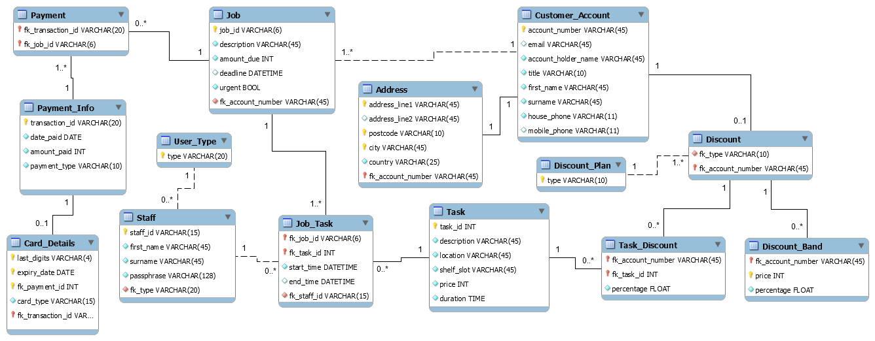

SQL Queries (insert here)

Graphical User Interface Models
- Pages
  - Page Tree
Home
Page 1
Page 2
Page 3
Page 4
Customer Account
Intervals
Backup
Users
Report
Place Order
Create Account
Job Process
Payment
Tasks
  - Home
    - User Interface
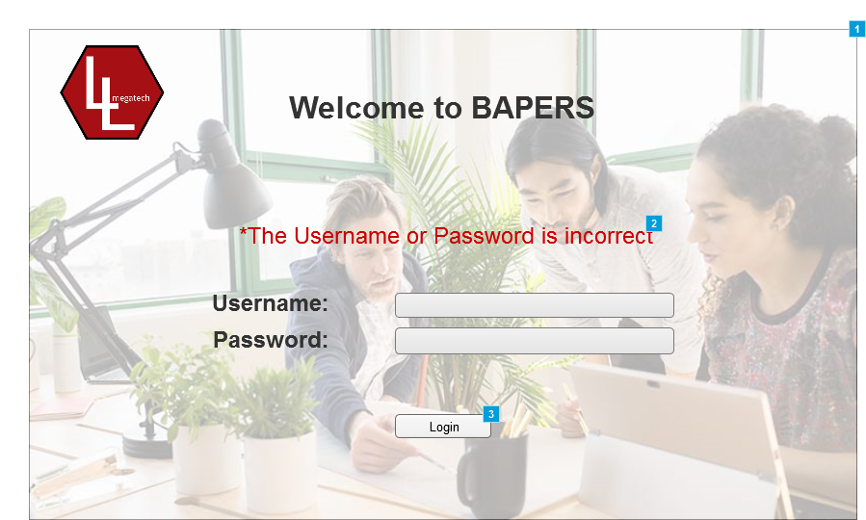
    - Widget Table
Footnote | Description | Risk
1 | Main login screen | Low
2 | Text that appears if the login details introduced are wrong
3 | When pressed, depending on the user and the details introduced, it either gives acces to the system or not.
  - Page 1
    - User Interface
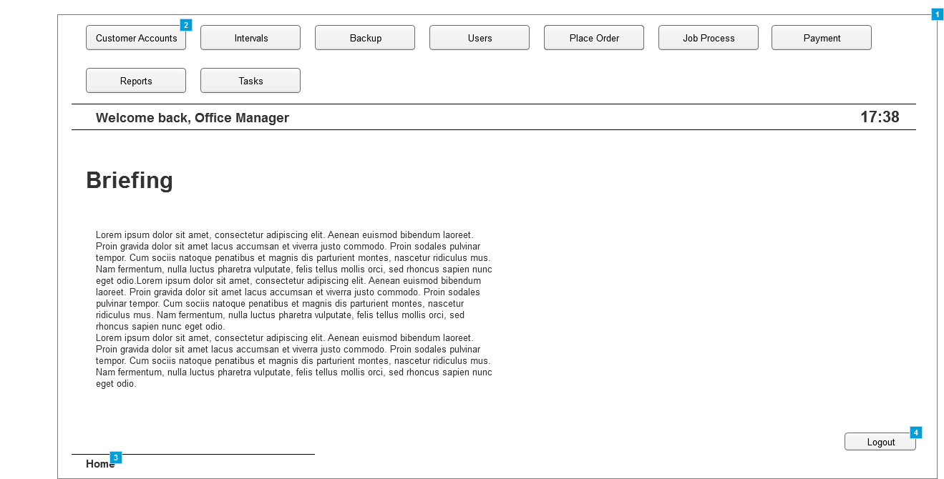
    - Widget Table
Footnote | Description
1 | Home screen panel for the Office Manager
2 | Buttons that when clicked, take the user to the screen described in the tab. Buttons change depending on the users and their permissions
3 | Displays the system path, for easier understanding where in the system the user is located. Can be clicked to go to a previous screen in that path,
4 | Button that, when clicked, logs the user out of the system.
  - Page 2
    - User Interface
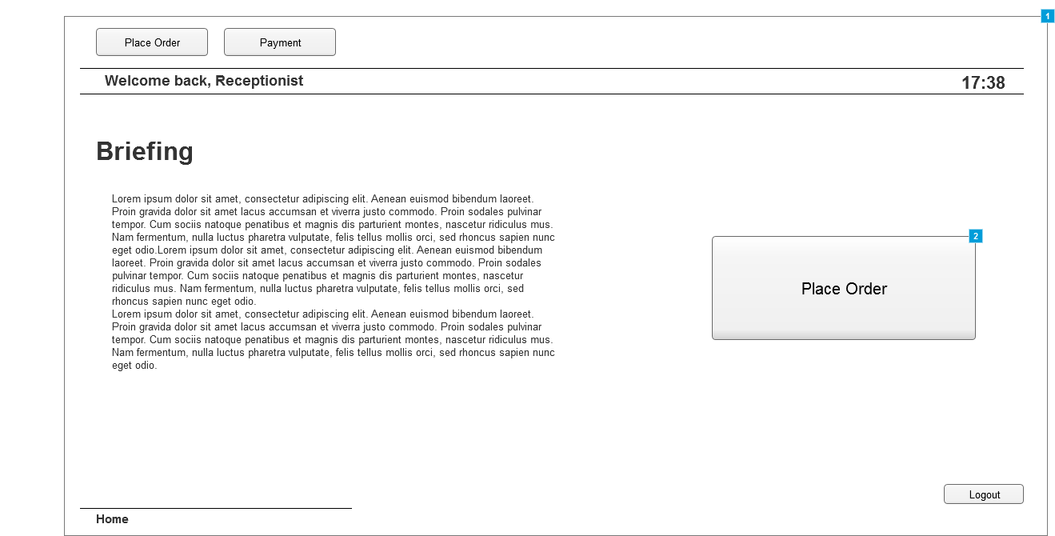
    - Widget Table
Footnote | Description
1 | Home screen panel for the Receptionist
2 | Quick access to "Place Order Tab" since is one of the main tasks.
  - Page 3
    - User Interface
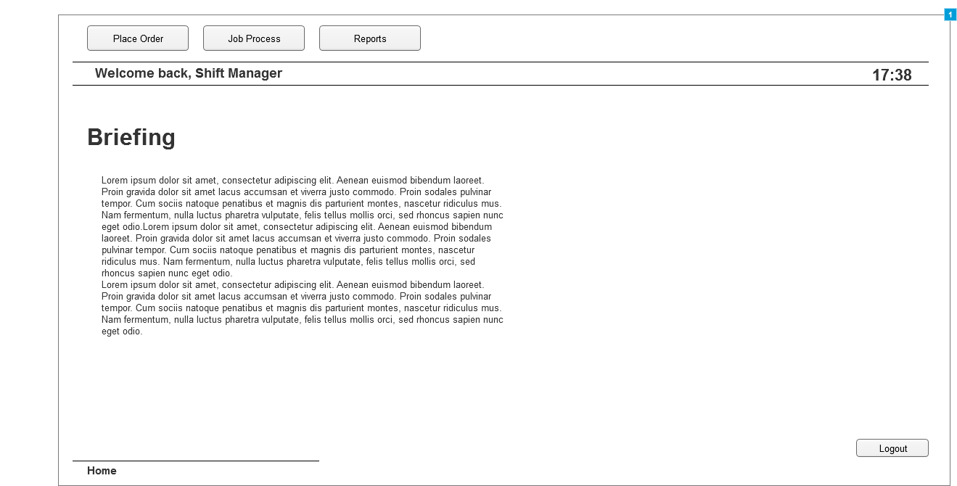
    - Widget Table
Footnote | Description
1 | Home screen panel for the Shift Manager
  - Page 4
    - User Interface
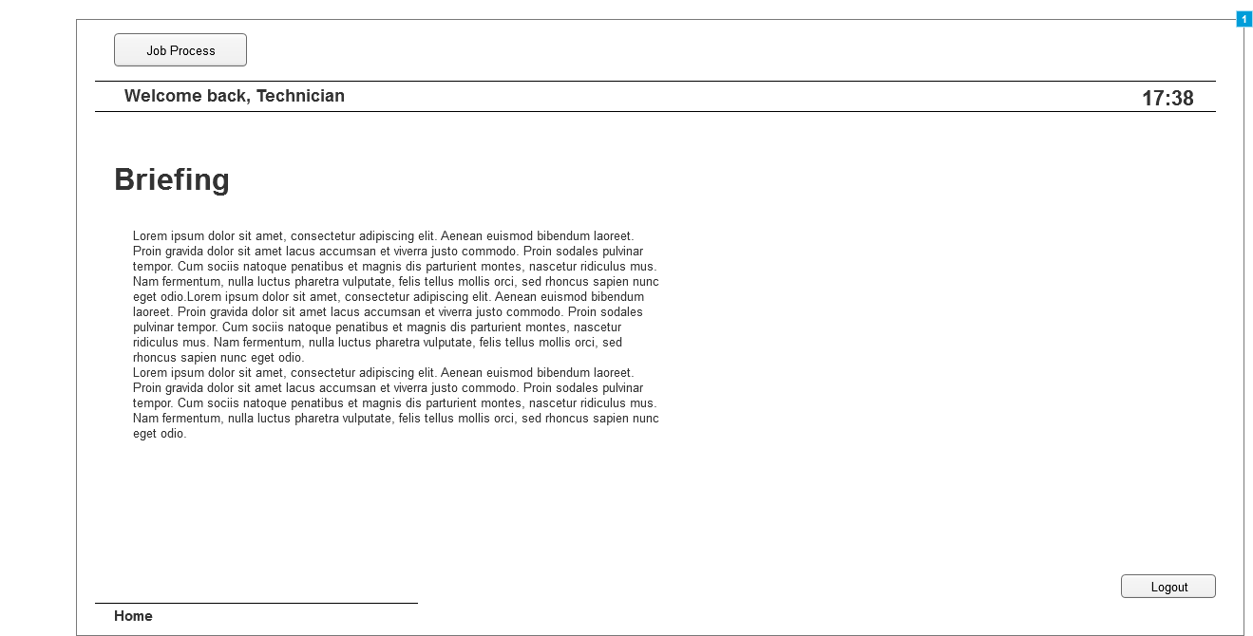
    - Widget Table
Footnote | Description
1 | Home screen panel for the Technician
  - Customer Account
    - User Interface
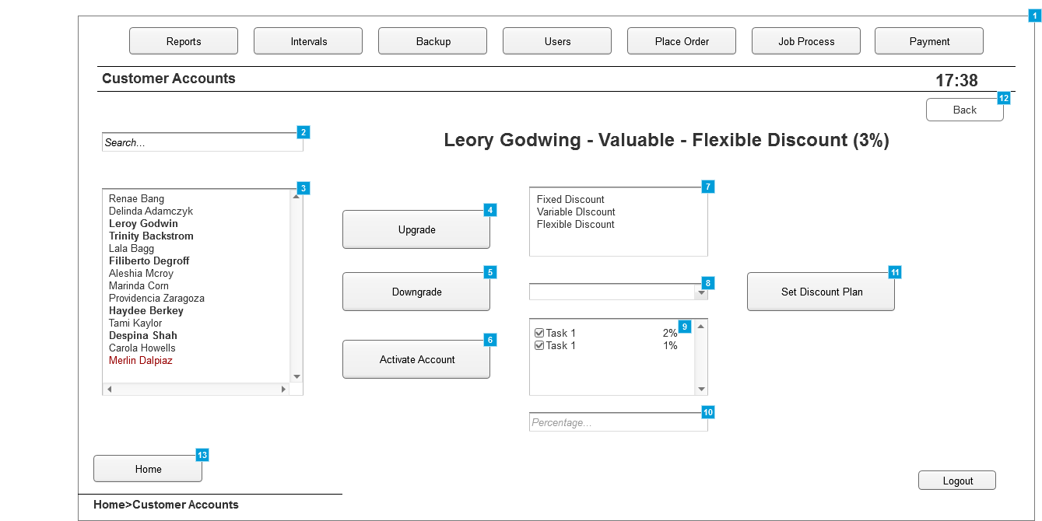
    - Widget Table
Footnote | Description
1 | Panel where the existing customer accounts are managed
2 | Search box, to look-up existing customer accounts, once chosen, upgrading/downgrading options are available as well as updating the discount plans associated with the account
3 | List box where all the existing customer accounts are displayed.  -The ones in Bold Display Valued Customers  -The normal ones display normal customers  -The ones in red display Suspended Customer Accounts
4 | Upgrades the customer to the "Valued" status, only available if the customer is not already in this status
5 | Downgrades the customer from the "Valued" status to the "Normal" one.
6 | Reactivates a "Suspended" account
7 | Panel displaying the available discount plans
8 | Tab that allows to choose tasks and apply discounts to each one. Appears only if "Flexible Discount" is selected
9 | If a discount for a task need to be deleted, unticking the box will do this. Selecting an existing task from the list and adding a different percentage will overwrite the previous one
10 | The percentage of the discount will be introduced here
11 | Button that, when clicked, confirms the discount options selected
12 | Button that allows the user to go back to the previous screen
13 | Button that takes the user to the home tab
  - Intervals
    - User Interface
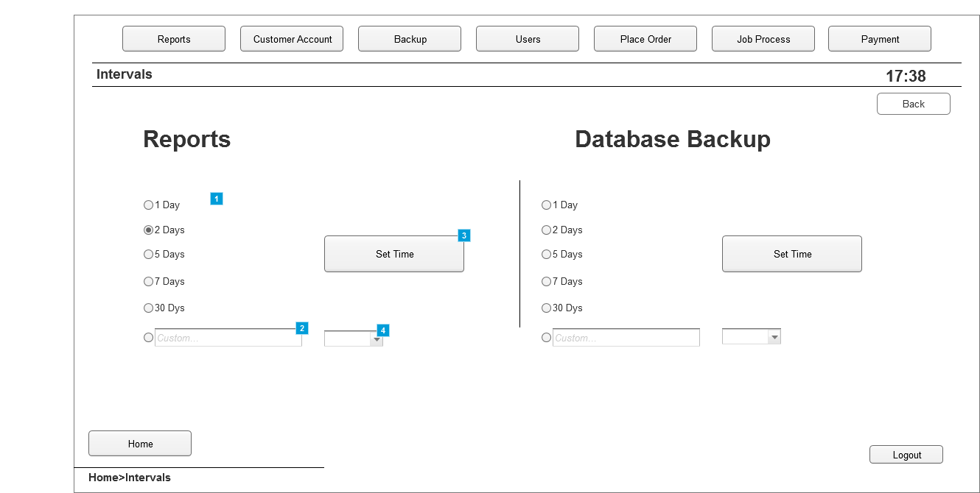
    - Widget Table
Footnote | Description
1 | Premade options to choose the time intervals at which reports are created. Similar for Database Backup
2 | Panel to introduce a custom time period for generating the repots. Same can be done to the Database Backup
3 | Button that, when clicked, sets the time intervals at which reports are created.
4 | Drop list allowing to set minutes, hours or days for the custom time intervals
  - Backup
    - User Interface
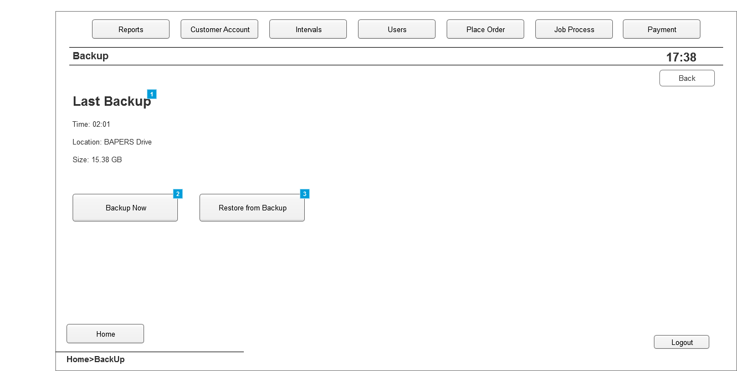
    - Widget Table
Footnote | Description
1 | Information about the last backup created
2 | Button that, when clicked, creates a system backup
3 | Button that, when clicked, restores data from the last backup created
  - Users
    - User Interface
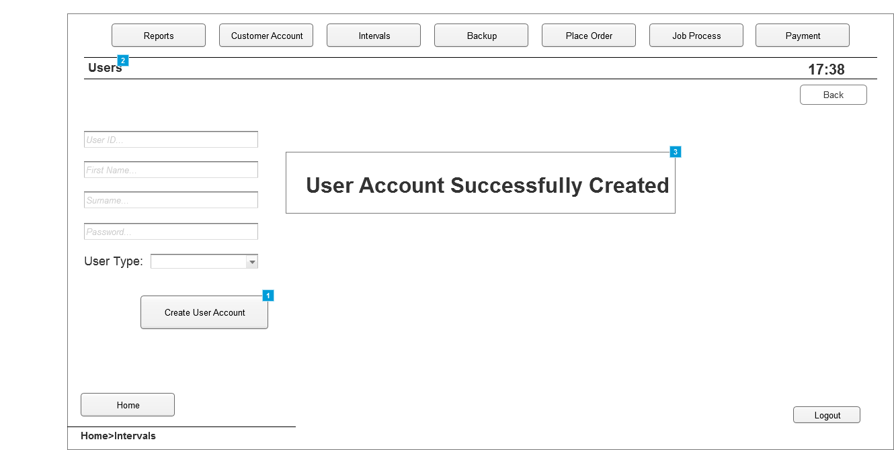
    - Widget Table
Footnote | Description
1 | Button that, when clicked, creates the user account with the details introduced
2 | Tab where new users are added to the system
3 | Window that pops up when an account has been successfully created
  - Report
    - User Interface
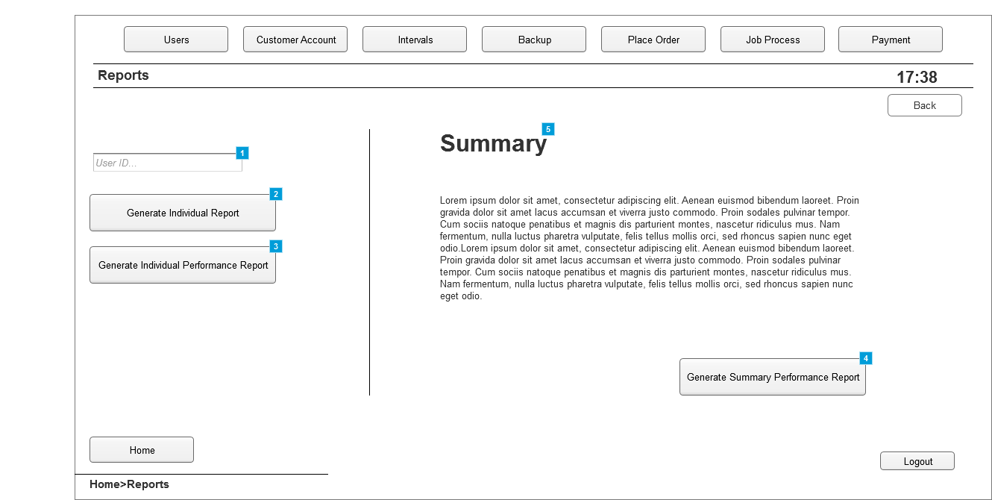
    - Widget Table
Footnote | Description
1 | Box where user ID is introduced. This refers to the system users. Once a user is selected, more options are available
2 | Button that, when clicked, generates an individual report for the user selected
3 | Button that, when clicked, generates an individual performance report for the user selected
4 | Button that, when clicked, generates a summary performance report
5 | Summary and details about it
  - Place Order
    - User Interface
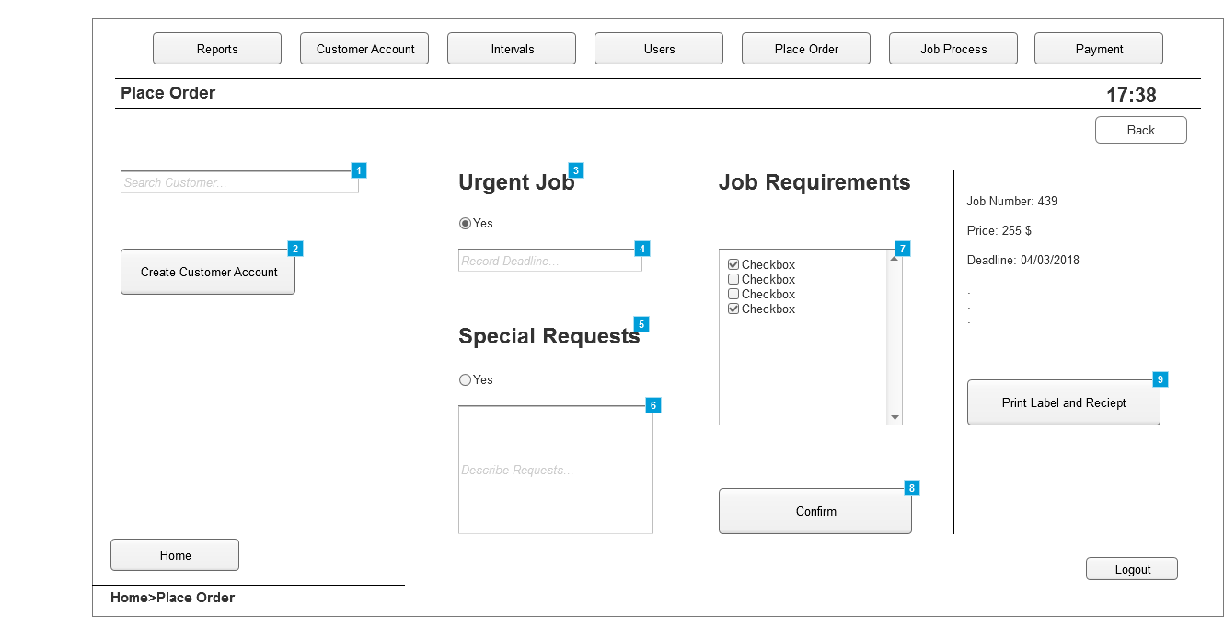
    - Widget Table
Footnote | Description
1 | Panel where customer accounts can be searched, if created, to allow for placing an order
2 | Button that, when clicked, takes the user to the "Create Account" window. Used in case the customer does not have an account yet
3 | Option to select if job placed is urgent.
4 | Panel to introduce deadline if job is urgent
5 | Option to select if special requests exist about the job
6 | Panel to introduce details about the request
7 | List of all tasks available. Checked only the ones which are needed for the job
8 | Button that, when clicked, generates the job number and final price
9 | Button that, when clicked, Assigns the job and prints the label and the reciept.
  - Create Account
    - User Interface
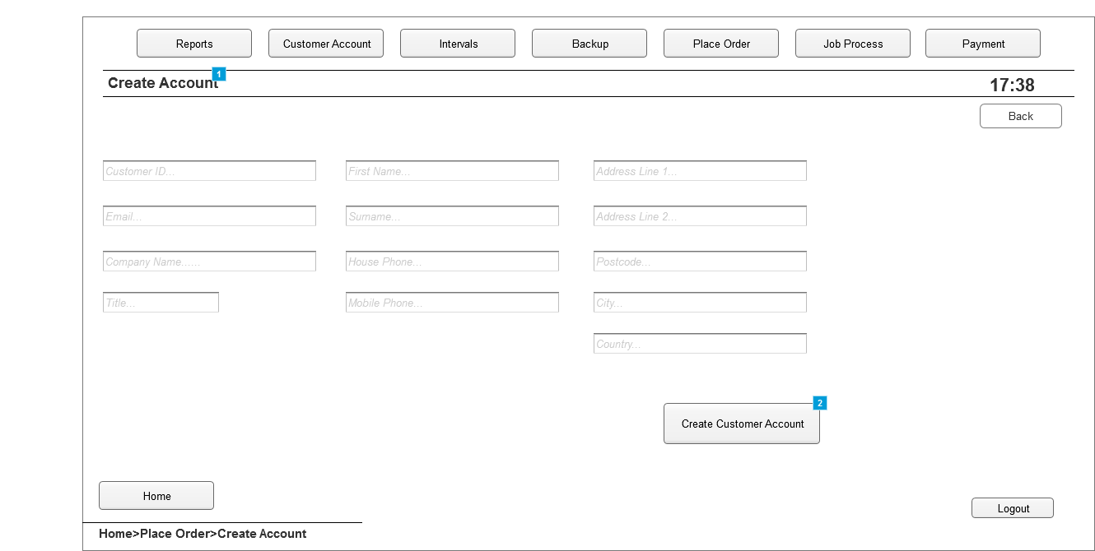
    - Widget Table
Footnote | Description
1 | Tab where new customer accounts are created
2 | Button that, when clicked, creates the customer account with the details introduced in each field.
  - Job Process
    - User Interface
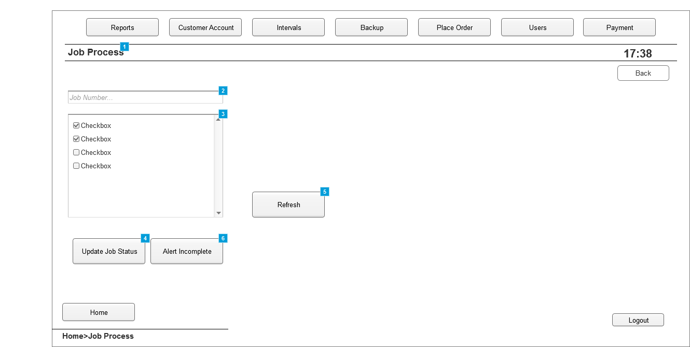
    - Widget Table
Footnote | Description
1 | Tab where the ongoing jobs can be managed
2 | Panel where the job number is introduced to get details about a job
3 | List with the tasks available. Those ticked indicate that the particular task is completed
4 | Button that, when clicked, updates the status of the jobs, A task must be ticked or unticked to be able to update
5 | Button that, when clicked, refreshes the list to see if changes have been made
6 | Button that is click to alert that the job is not going to be completed on time
  - Payment
    - User Interface
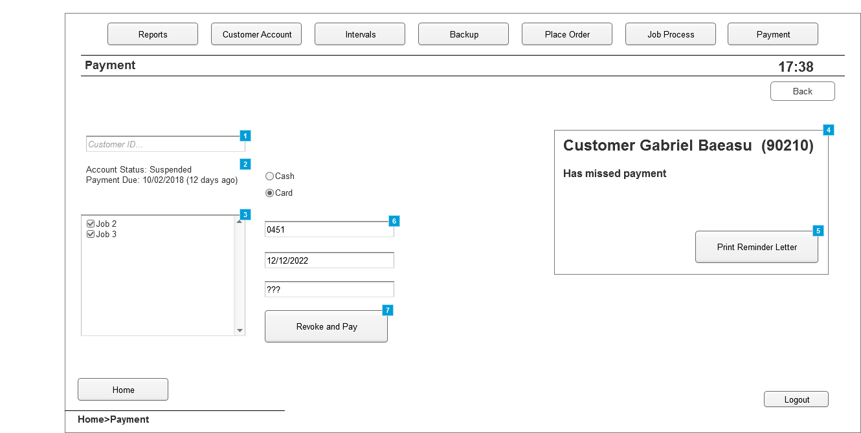
    - Widget Table
Footnote | Description
1 | Panel where a customer is searched to get details about the job placed
2 | Details about the customer account,
3 | List of all the jobs placed, only one will be displayed if the customer is not "Valued"  If the job is ticked, it means it will be paid for in the next payment.
4 | Pop-up window alerting the Office Manager that a customer has missed payment
5 | Button that, when clicked will print the reminder letter for the user
6 | Panels where information about card or cash payment is introduced
7 | Button that, when clicked, completes payment and revokes suspension of an account if account is suspended.
  - Tasks
    - User Interface
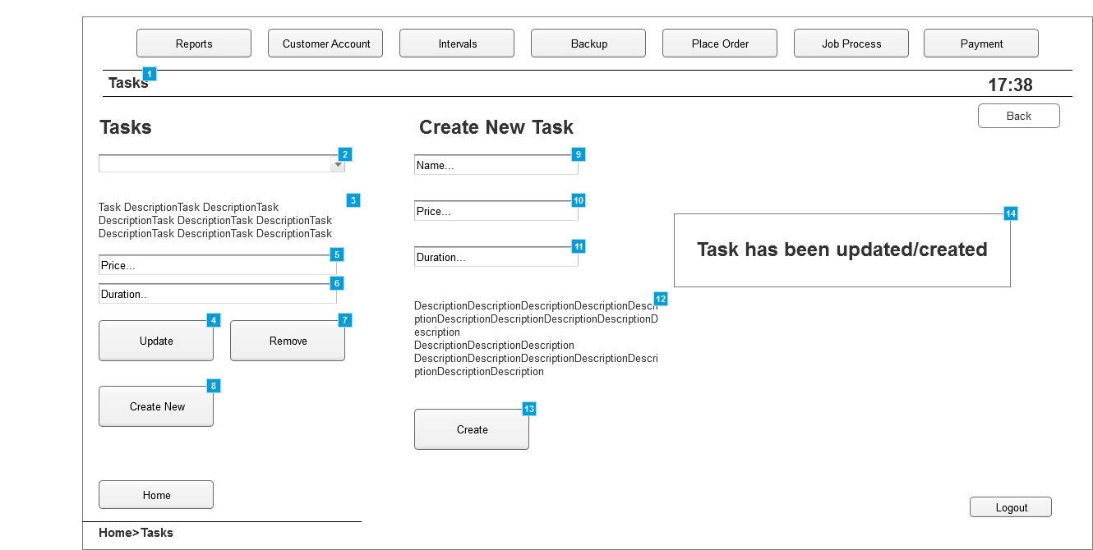
    - Widget Table
Footnote | Description
1 | Tab where tasks can be managed
2 | List of all the tasks available in the system
3 | Description of the task selected
4 | Button that. when clicked, updates any details changed about the selected task
5 | Price of the selected task
6 | Time it takes for the task to be completed
7 | Button that. when clicked, removes the selected task
8 | Button that. when clicked, displays the "Create Task" options
9 | Panel to introduce the name of the new task
10 | Panel to introduce the price of the new task
11 | Panel to introduce the time taken for the new task to be completed
12 | Description of the new task
13 | Button that, when clicked, creates and adds the task to the list of existing tasks.
14 | Window that pops up when a task has been successfully created or updated

